- Factorial of a number
Aim:
To create a flowchart for finding the factorial of a number using Raptor software.

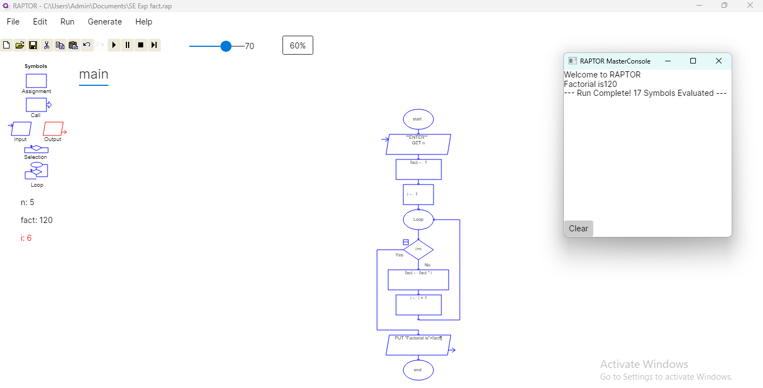

- Prime number:
Aim:
To create a flowchart to check whether a number is prime or not using Raptor software.

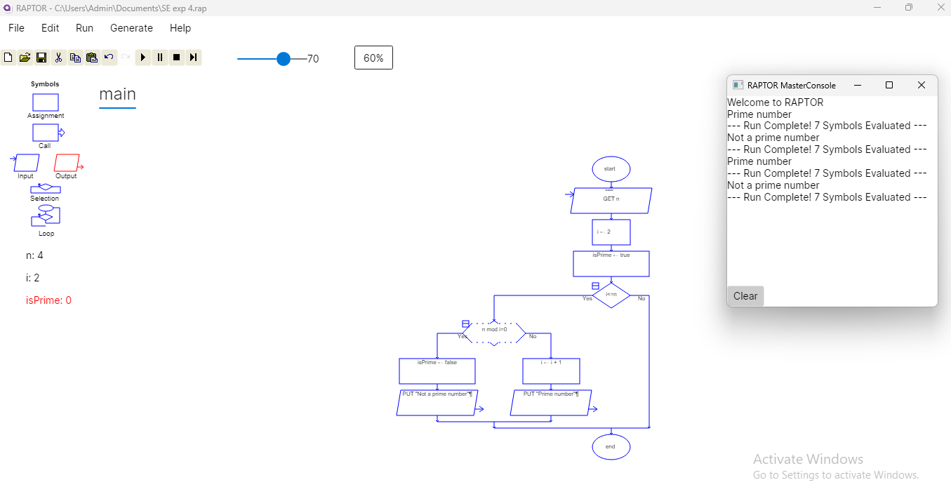
- Armstrong number
Aim:
To create a flowchart to check whether a number is armstrong or not using Raptor software.

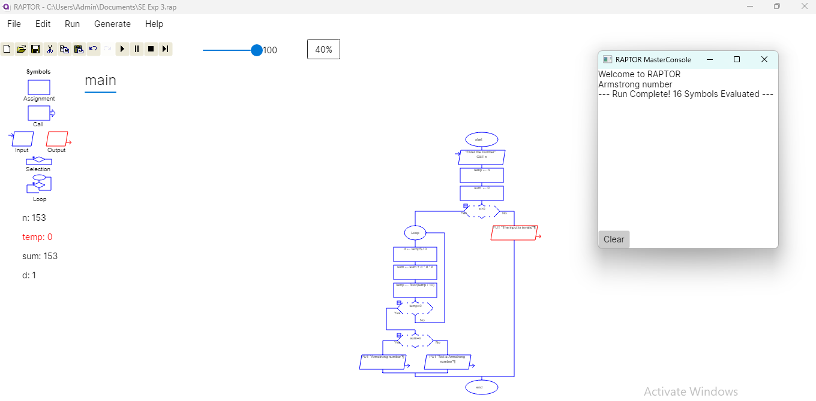

- Greatest among three number
Aim:
To create a flowchart to find the greatest among three numbers using Raptor software.

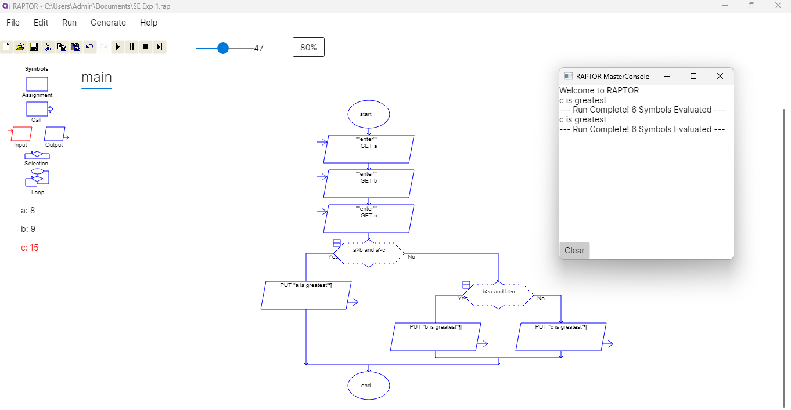

- Length of a string
Aim:
To create a flowchart to find length of a string using Raptor software.

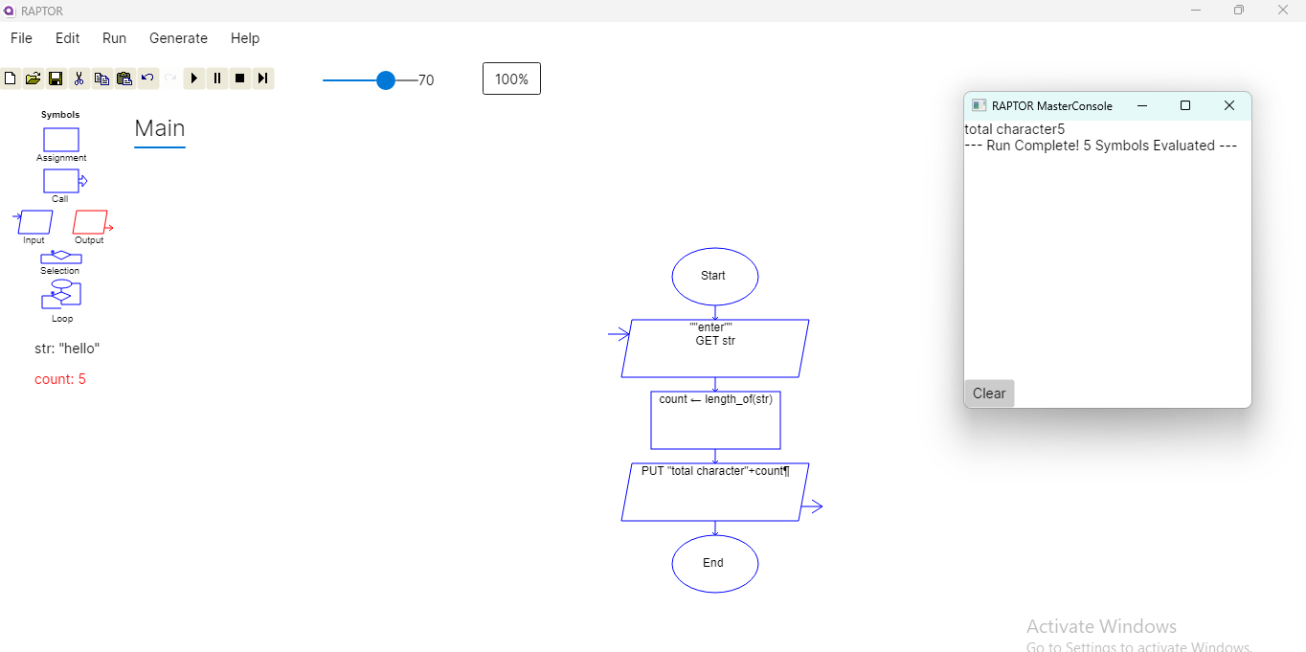

- Cyclometric complexity:
Aim:
To create a flowchart to solve the cyclometric complexity using Raptor software.
